**Dokumentasi Pertemuan 2**

Nama : Rendragraha Verdiansyah

NIM : A11.2020.12846

Kelompok : A11.4301

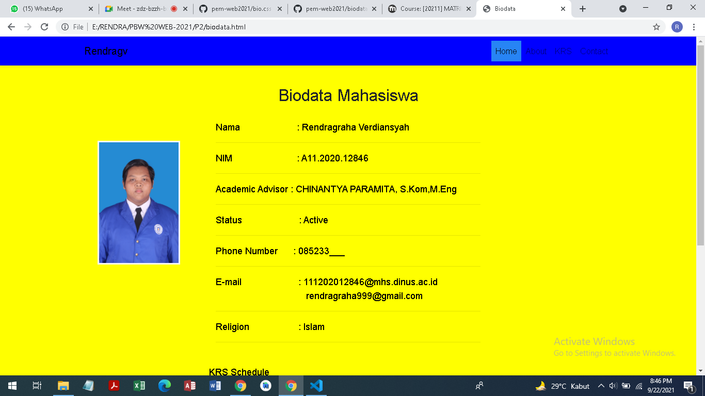

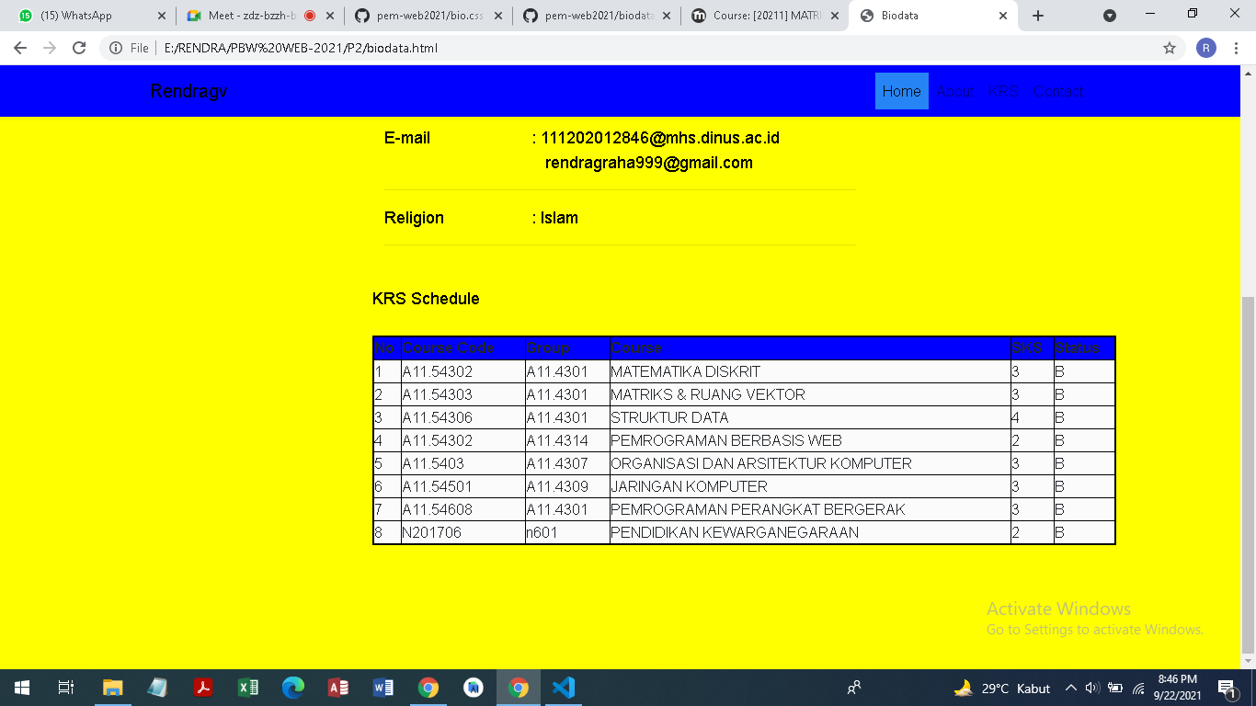

**Biodata.html:**

<!doctype html>

<html lang="en">

  <head>

    <!-- Required meta tags -->

    <meta charset="utf-8">

    <meta name="viewport" content="width=device-width, initial-scale=1, shrink-to-fit=no">

    <!-- Bootstrap CSS -->

    <link rel="stylesheet" href="https://cdn.jsdelivr.net/npm/bootstrap@4.5.3/dist/css/bootstrap.min.css" integrity="sha384-TX8t27EcRE3e/ihU7zmQxVncDAy5uIKz4rEkgIXeMed4M0jlfIDPvg6uqKI2xXr2" crossorigin="anonymous">

    <link rel="stylesheet" type="text/css" href="bio.css">

    <title>Biodata</title>

  </head>

  <body style="background-color:yellow;">

    <nav class="navbar fixed-top navbar-expand-lg navbar-light shadow-sm" style="background-color:blue;">

        <div class="container">

            <a class="navbar-brand" href="#">Rendragv</a>

            <button class="navbar-toggler" type="button" data-toggle="collapse" data-target="#navbarNav" aria-controls="navbarNav" aria-expanded="false" aria-label="Toggle navigation">

            <span class="navbar-toggler-icon"></span>

            </button>

        <div class="collapse navbar-collapse" id="navbarNav">

          <ul class="navbar-nav ml-auto">

            <li class="nav-item active">

              <a class="nav-link" href="biodata.html">Home <span class="sr-only">(current)</span></a>

            </li>

            <li class="nav-item">

              <a class="nav-link" href="#l">About</a>

            </li>

            <li class="nav-item">

              <a class="nav-link" href="#">KRS</a>

            </li>

            <li class="nav-item">

              <a class="nav-link" href="#">Contact</a>

            </li>

          </ul>

        </div>

         </div>

    </nav>

    <div class=BioMhs>

        <h2 style="text-align:center">Biodata Mahasiswa</h2>

    </div>

    <div class=ko2>

        <font color="black" size="4" face="calibri">Nama &nbsp;&nbsp;&nbsp;&nbsp;&nbsp;&nbsp;&nbsp;&nbsp;&nbsp;&nbsp;&nbsp;&nbsp;&nbsp;&nbsp;&nbsp;&nbsp;&nbsp;&nbsp;&nbsp;&nbsp;&nbsp;: Rendragraha Verdiansyah</font><hr>

        <font color="black" size="4" face="calibri">NIM &nbsp;&nbsp;&nbsp;&nbsp;&nbsp;&nbsp;&nbsp;&nbsp;&nbsp;&nbsp;&nbsp;&nbsp;&nbsp;&nbsp;&nbsp;&nbsp;&nbsp;&nbsp;&nbsp;&nbsp;&nbsp;&nbsp;&nbsp;&nbsp;: A11.2020.12846</font><hr>

        <font color="black" size="4" face="calibri">Academic Advisor : CHINANTYA PARAMITA, S.Kom,M.Eng</font><hr>

        <font color="black" size="4" face="calibri">Status  &nbsp;&nbsp;&nbsp;&nbsp;&nbsp;&nbsp;&nbsp;&nbsp;&nbsp;&nbsp;&nbsp;&nbsp;&nbsp;&nbsp;&nbsp;&nbsp;&nbsp;&nbsp;&nbsp;&nbsp;&nbsp;: Active</font><hr>

        <font color="black" size="4" face="calibri">Phone Number  &nbsp;&nbsp;&nbsp;&nbsp;&nbsp;: 085233___</font><hr>

        <font color="black" size="4" face="calibri">E-mail &nbsp;&nbsp;&nbsp;&nbsp;&nbsp;&nbsp;&nbsp;&nbsp;&nbsp;&nbsp;&nbsp;&nbsp;&nbsp;&nbsp;&nbsp;&nbsp;&nbsp;&nbsp;&nbsp;&nbsp;&nbsp;: 111202012846@mhs.dinus.ac.id<br>

&nbsp;&nbsp;&nbsp;&nbsp;&nbsp;&nbsp;&nbsp;&nbsp;&nbsp;&nbsp;&nbsp;&nbsp;&nbsp;&nbsp;&nbsp;&nbsp;&nbsp;&nbsp;&nbsp;&nbsp;&nbsp;&nbsp;&nbsp;&nbsp;&nbsp;&nbsp;&nbsp;&nbsp;&nbsp;&nbsp;&nbsp;&nbsp;&nbsp;&nbsp;&nbsp;rendragraha999@gmail.com</font><hr>

        <font color="black" size="4" face="calibri">Religion &nbsp;&nbsp;&nbsp;&nbsp;&nbsp;&nbsp;&nbsp;&nbsp;&nbsp;&nbsp;&nbsp;&nbsp;&nbsp;&nbsp;&nbsp;&nbsp;&nbsp;&nbsp;: Islam</font><hr>

    </div>

    <img src="4x6.jpg" alt="4x6" width=160cm height=240cm style="border:3px solid #F8F8FF">

    <div class=krs>

        <font color="black" size="4" face="calibri">KRS Schedule</font>

    </div>

    <div class=tabel style="background-color:rgb(251, 251, 251);">

        <table style="width:100%">

            <tr>

                <th>No</th>

                <th>Course Code</th>

                <th>Group</th>

                <th>Course</th>

                <th>SKS</th>

                <th>Status</th>

            </tr>

            <tr>

                <td>1</td>

                <td>A11.54302</td>

                <td>A11.4301</td>

                <td>MATEMATIKA DISKRIT</td>

                <td>3</td>

                <td>B</td>

            </tr>

            <tr>

                <td>2</td>

                <td>A11.54303</td>

                <td>A11.4301</td>

                <td>MATRIKS & RUANG VEKTOR</td>

                <td>3</td>

                <td>B</td>

            </tr>

            <tr>

                <td>3</td>

                <td>A11.54306</td>

                <td>A11.4301</td>

                <td>STRUKTUR DATA</td>

                <td>4</td>

                <td>B</td>

            </tr>

            <tr>

                <td>4</td>

                <td>A11.54302</td>

                <td>A11.4314</td>

                <td>PEMROGRAMAN BERBASIS WEB</td>

                <td>2</td>

                <td>B</td>

            </tr>

            <tr>

                <td>5</td>

                <td>A11.5403</td>

                <td>A11.4307</td>

                <td>ORGANISASI DAN ARSITEKTUR KOMPUTER</td>

                <td>3</td>

                <td>B</td>

            </tr>

            <tr>

                <td>6</td>

                <td>A11.54501</td>

                <td>A11.4309</td>

                <td>JARINGAN KOMPUTER</td>

                <td>3</td>

                <td>B</td>

            </tr>

            <tr>

                <td>7</td>

                <td>A11.54608</td>

                <td>A11.4301</td>

                <td>PEMROGRAMAN PERANGKAT BERGERAK</td>

                <td>3</td>

                <td>B</td>

            </tr>

            <tr>

                <td>8</td>

                <td>N201706</td>

                <td>n601</td>

                <td>PENDIDIKAN KEWARGANEGARAAN</td>

                <td>2</td>

                <td>B</td>

            </tr>

        </table>

    </div>

    <!-- Option 1: jQuery and Bootstrap Bundle (includes Popper) -->

    <script src="https://code.jquery.com/jquery-3.5.1.slim.min.js" integrity="sha384-DfXdz2htPH0lsSSs5nCTpuj/zy4C+OGpamoFVy38MVBnE+IbbVYUew+OrCXaRkfj" crossorigin="anonymous"></script>

    <script src="https://cdn.jsdelivr.net/npm/bootstrap@4.5.3/dist/js/bootstrap.bundle.min.js" integrity="sha384-ho+j7jyWK8fNQe+A12Hb8AhRq26LrZ/JpcUGGOn+Y7RsweNrtN/tE3MoK7ZeZDyx" crossorigin="anonymous"></script>

    <!-- Option 2: jQuery, Popper.js, and Bootstrap JS

    <script src="https://code.jquery.com/jquery-3.5.1.slim.min.js" integrity="sha384-DfXdz2htPH0lsSSs5nCTpuj/zy4C+OGpamoFVy38MVBnE+IbbVYUew+OrCXaRkfj" crossorigin="anonymous"></script>

    <script src="https://cdn.jsdelivr.net/npm/popper.js@1.16.1/dist/umd/popper.min.js" integrity="sha384-9/reFTGAW83EW2RDu2S0VKaIzap3H66lZH81PoYlFhbGU+6BZp6G7niu735Sk7lN" crossorigin="anonymous"></script>

    <script src="https://cdn.jsdelivr.net/npm/bootstrap@4.5.3/dist/js/bootstrap.min.js" integrity="sha384-w1Q4orYjBQndcko6MimVbzY0tgp4pWB4lZ7lr30WKz0vr/aWKhXdBNmNb5D92v7s" crossorigin="anonymous"></script>

    -->

  </body>

</html>

**Bio.css**

.ko1{

    margin:-0.7% -0.7%;

    position:absolute;

    width:98.1%;

    height:17%;

    padding:0% 1%;

    background-color: blue;

}

.BioMhs{

    margin:7% 25%;

    position:absolute;

    width:50%;

    height:17%;

    padding:1px;

}

.ko2{

    margin:12% 30%;

    position:absolute;

    width:40%;

    height:10%;

    padding:0% 1%;

    /* background-color: red; */

}

.fa {

  padding: -3% -2%;

  font-size: 30px;

  width: 30px;

  text-align: center;

  text-decoration: none;

  margin: 0% 0.5%;

}

.fa:hover {

    opacity: 0.7;

}

.fa-facebook {

  /* background: #3B5998; */

  color: white;

}

.fa-instagram {

  /* background: #125688; */

  color: white;

}

.fa-twitter {

  /* background: #55ACEE; */

  color: white;

}

img  {

    margin: 15% 14%;

}

.krs{

    margin: -8% 30%;

    padding-top: 100px;

}

.tabel{

    margin: 10% 30%;

    width: 60%;

    border: 1px solid black;

}

table, th, td {

  border:1px solid black;

}

th{

    background-color: blue;

}

.org{

    margin: -5% 30%;

}

.tabel2{

    margin: 7% 30%;

    width: 50%;

    border: 1px solid black;

}

*{

    padding:0;

    margin:0;

    font-family: sans-serif;

}

a{

    color: inherit;

    text-decoration: none;

}

.medsos {

    padding:5px 0;

    background-color: #2784F4;

}

.medsos ul li {

    display: inline-block;

    color: #fff;

    margin-right: 10px;

}

.container {

    width:80%;

    margin:0 auto;

}

.container:after {

    content:'';

    display: block;

    clear: both;

}

header h1 {

    float: left;

    padding:15px 0;

    color: #2784F4;

}

header ul {

    float:right;

}

header ul li {

    display: inline-block;

}

header ul li a {

    padding:25px 20px;

    display: inline-block;

}

header ul li a:hover {

    background-color: #2784F4;

    color: #fff;

}

.active {

    background-color: #2784F4;

    color: #fff;

}

.banner {

    height: 60vh;

    background-image: url('../img/banner.jpg');

    background-size: cover;

    position: relative;

    display: flex;

    justify-content: center;

    align-items: center;

}

.banner:after {

    content: '';

    display: block;

    position: absolute;

    top: 0;

    left: 0;

    right: 0;

    bottom: 0;

    background-color:rgba(213, 245, 227, 0.6);

}

.banner h2{

    color: #fff;

    z-index: 1;

    padding: 20px 25px;

    border:4px solid #fff;

}

section {

    padding:90px 0;

}

section h3{

    text-align: center;

    padding: 20px 0;

    color: #2784F4;

    margin-bottom: 20px;

}

.about,

.service {

    padding-bottom: 100px;

}

.about p {

    color: #2784F4;

    word-spacing: 2px;

    line-height: 25px;

    text-align: center;

}

.service {

    background-color: #f9f9f9;

}

.box {

    color: #2784F4;

}

.box:after {

    content: '';

    display: block;

    clear: both;

}

.box .col-4 {

    width:25%;

    padding:20px;

    box-sizing: border-box;

    text-align: center;

    float: left;

}

.icon {

    width:70px;

    height:70px;

    border:1px solid;

    border-radius: 50%;

    text-align: center;

    line-height: 70px;

    font-size: 30px;

    margin:0 auto;

}

.box .col-4 h4 {

    margin:20px 0;

}

footer {

    padding:30px 0;

    background-color: #333;

    color: #fff;

    text-align: center;

}

.bg-loader {

    background-color: #eee;

    position: fixed;

    top: 0;

    left: 0;

    right: 0;

    bottom: 0;

    z-index: 9999;

    display: flex;

    justify-content: center;

    align-items: center;

}

.bg-loader  .loader {

    width:100px;

    height: 100px;

    border:3px solid #fff;

    border-radius: 50%;

    border-top-color: #2784F4;

    border-right-color: #2784F4;

    border-bottom-color: #2784F4;

    animation: puterin .5s linear infinite;

}

.label {

    background-color: #D5F5E3;

    color: #2784F4;

}

@keyframes puterin{

    100% {

        transform: rotate(360deg);

    }

}

@media screen and (max-width: 768px){

    .container {

        width: 90%;

    }

    header h1 {

        text-align: center;

        float: none;

    }

    header ul {

        text-align: center;

        float: none;

    }

    .box .col-4 {

        width:100%;

        float: none;

        margin-bottom: 20px;

    }

}